DBMS EXP 4

1.Show the structure of departments the table. Select all the data from it. 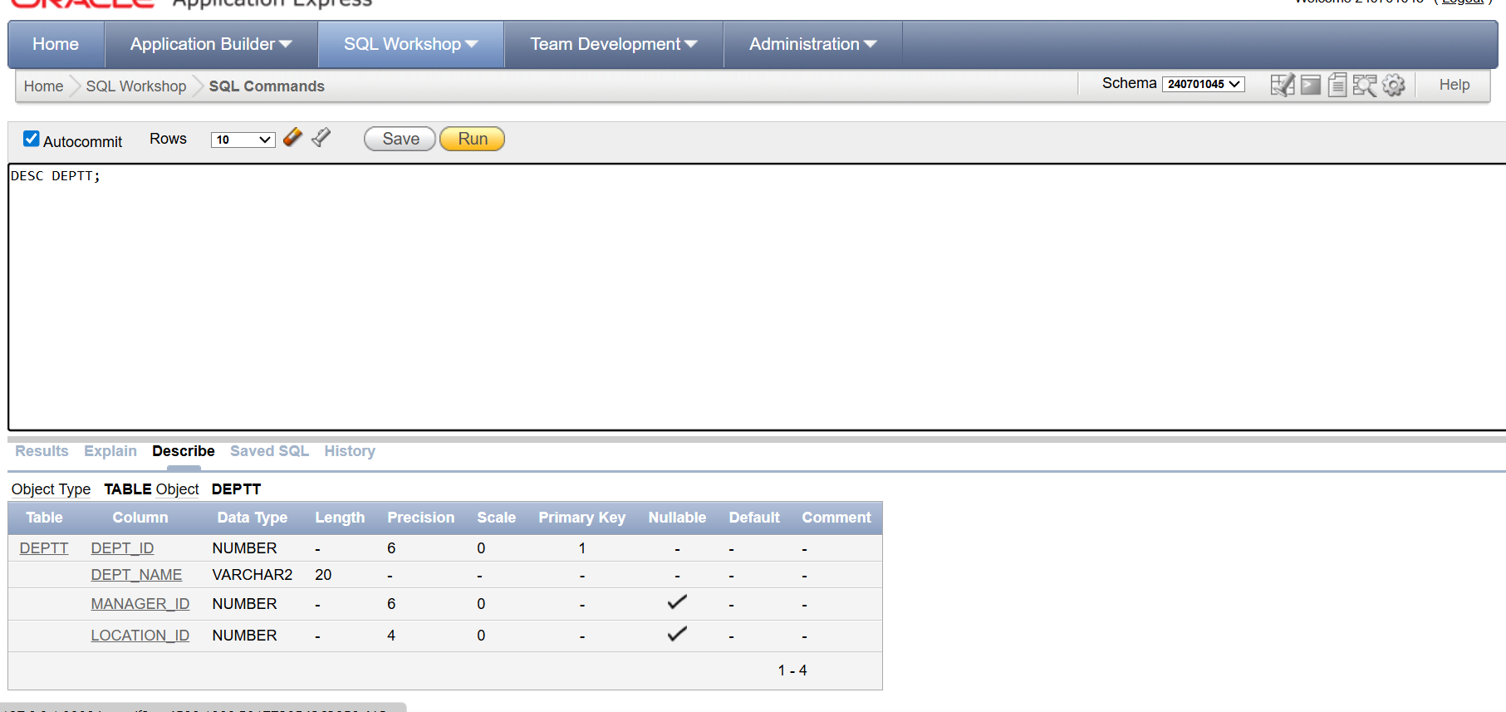

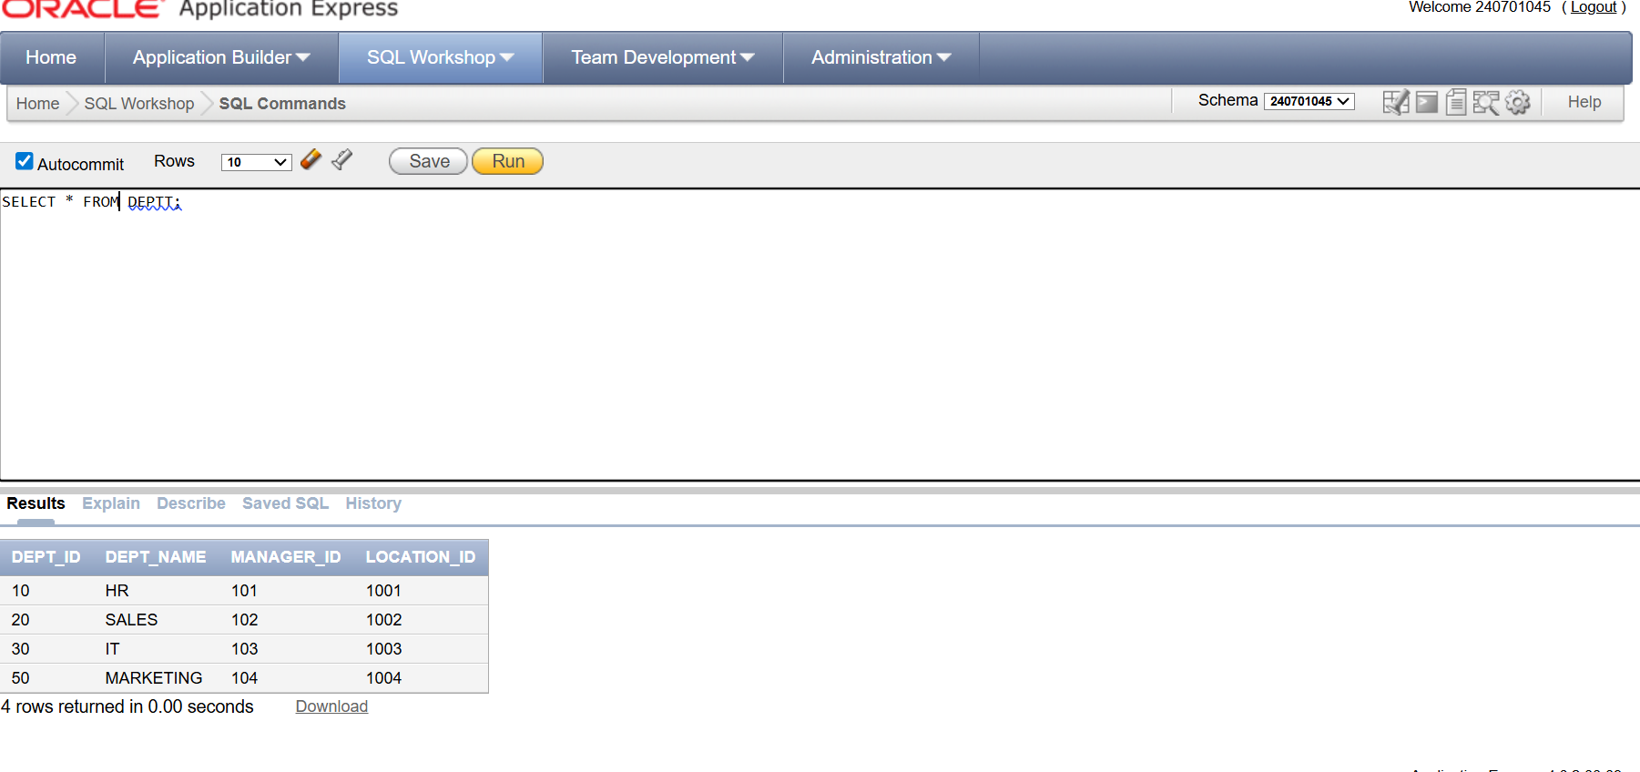

2.Create a query to display the last name, job code, hire date, and employee number for each employee, with employee number appearing first. 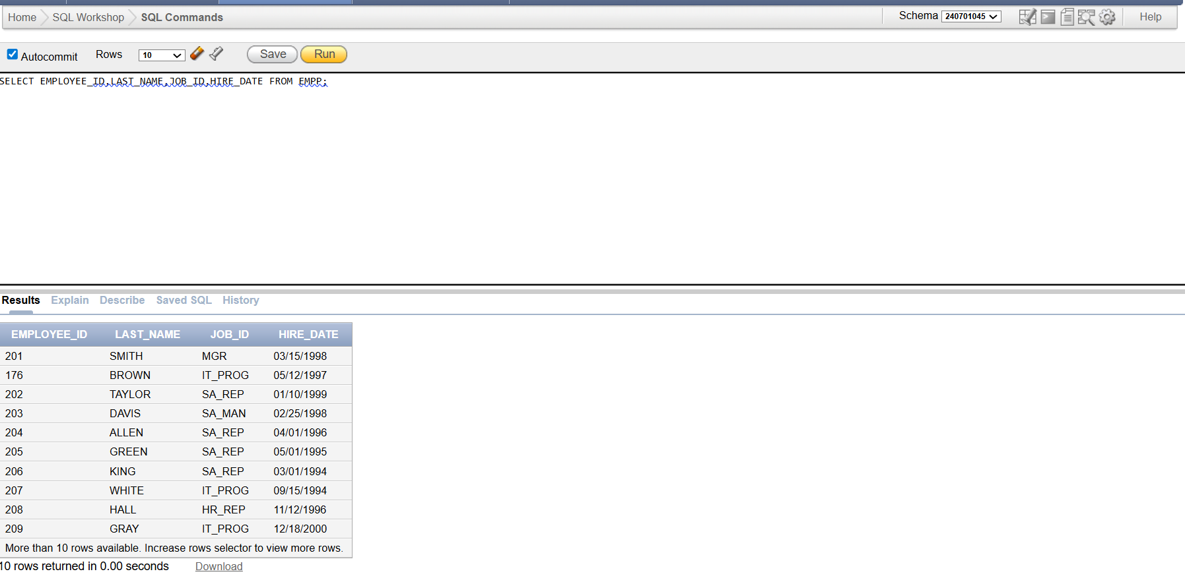

3.Provide an alias STARTDATE for the hire date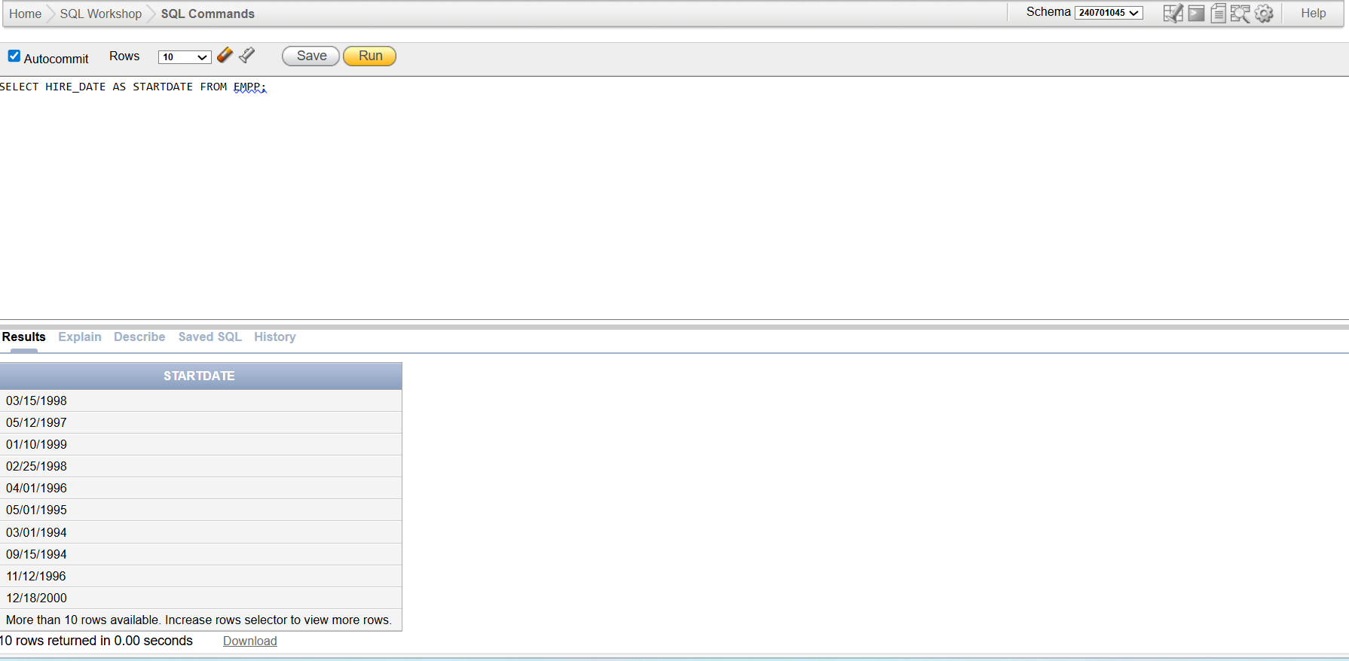

4.Create a query to display unique job codes from the employee table. 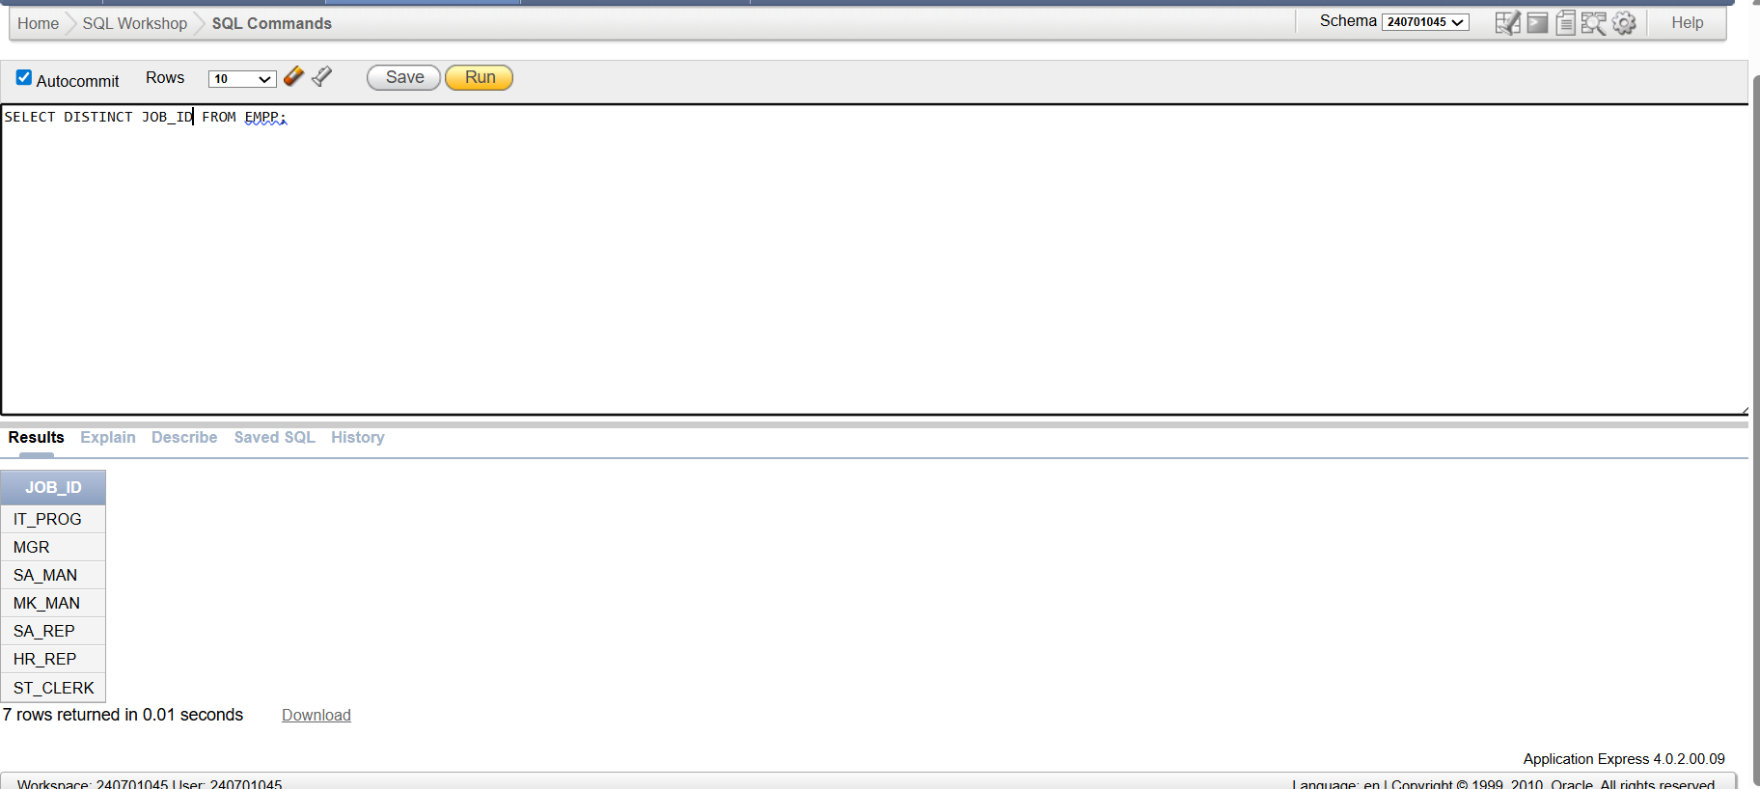

5.Display the last name concatenated with the job ID , separated by a comma and space, and name the column EMPLOYEE and TITLE.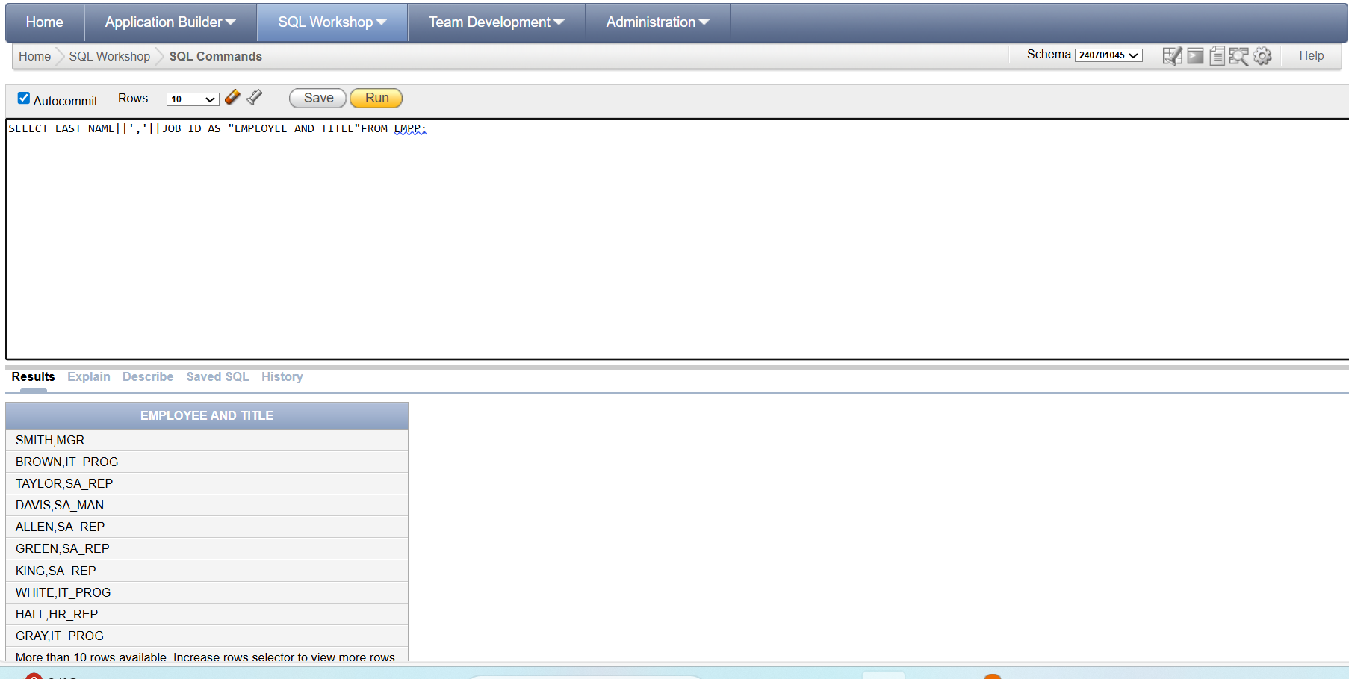

6.Create a query to display all the data from the employees table. Separate each column by a comma. Name the column THE_OUTPUT. 